|  |
| --- |
| **VISVESVARAYA TECHNOLOGICAL UNIVERSITY**  **BELAGAVI - 590 018, KARNATAKA**    *A Mini Project Report on*  **“Fitness App”**  Submitted in the partial fulfillment for the requirements for the Mobile Application Development Lab  with Mini Project (18CSMP68)  in  **INFORMATION SCIENCE AND ENGINEERING**  By  **Ms. MANASA C B USN: 1BY20IS077**  **Mr. MANISH KUMAR USN:1BY20IS078**    Under the guidance of  **Dr. Geeta Patil**  Associate Professor  Department of ISE, BMSIT&M.    **DEPARTMENT OF INFORMATION SCIENCE AND ENGINEERING**  **BMS INSTITUTE OF TECHNOLOGY & MANAGEMNT YELAHANKA, BENGALURU-560064**  **2022-2023** |

**VISVESVARAYA TECHNOLOGICAL UNIVERSITY**

**BELAGAVI – 590 018, KARNATAKA**

**BMS INSTITUTE OF TECHNOLOGY & MANAGEMENT**

**YELAHANKA, BENGALURU-560064**

**DEPARTMENT OF INFORMATION SCIENCE & ENGINEERING**



**CERTIFICATE**

This is to certify that the Project work entitled **“Fitness App”** is a bonafide work carried out

by **Ms. Manasa C B (1BY20IS077) and Mr. Manish Kumar (1BY20IS078)** in partial fulfillment of Mobile Application Development Laboratory with Mini Project (18CSMP68) for the award of **Bachelor of Engineering Degree in Information Science and Engineering** of the Visvesvaraya Technological University, Belagavi during the year 2022-23. It is certified that all corrections/suggestions indicated for Internal Assessment have been incorporated in this report. The project report has been approved as it satisfies the academic requirements in respect of Mini Project work for the B.EDegree.

**Signature of the Guide Signature of the HOD**  Dr. Geetha Patil Dr. Pushpa S.K.

Associate Professor Professor and Head

Department of ISE Department of ISE

**EXTERNAL EXAMINERS**

Name of the Examiners Signature with Date 1.

2.

# ACKNOWLEDGEMENT

We are happy to present this mini project after completing it successfully. This mini project would not have been possible without the guidance, assistance and suggestions of many individuals. We would like to express our deep sense of gratitude and indebtedness to each and every one who has helped us make this mini project a success.

We heartly thank our **Principal, Dr. Mohan Babu G.N,** **B M S Institute of Technology & Management** for his constant encouragement and inspiration in taking up this mini project.

We heartly thank our **Head of Department, Dr. Pushpa S.K, Dept. of Information Science** **and** **Engineering, B M S Institute of Technology& Management** for her constant encouragement and inspiration in taking up this mini project.

We gracefully thank our Project guide**, Dr. Geeta Patil., Associate Professor, Dept. of** **Information Science and Engineering,** for her encouragement and advice throughout the course of the mini project work.

Special thanks to all the staff members of Information Science Department for their help and kind co-operation.

We also thank our parents and friends for their unconditional love and encouragement and support given to us in order to finish this precious work.

Last but not the least we would like to thank God for giving us the strength and motivation through the course of this Project.

By,

Manasa C B

Manish Kumar

# ABSTRACT

Fitness apps are promising digital tools to support self-tracking and physical activity. Specific app functions such as normalized step targets represent controlling conditions that can affect controlled vs. autonomous motivation and thus motivated physical activity.

Physical activity increased in the fitness tracker groups compared to the control group. Moderate physical activity and autonomy need satisfaction increased in the ENT group. Identified motivation decreased in the ET and control groups and introjected motivation decreased in the control group. Amotivation increased in the ENT group. Conclusively, self-tracking via fitness apps can support physical activity, and normalized step targets can undermine motivation. Lack of normalized targets can support autonomy need satisfaction and physical activity but can also foster amotivation. Thus, it is advised to support autonomous goal setting in fitness app users.

The sports apps promoted people's exercise behaviour and habits significantly. It can exercise anytime, anywhere, on-demand occurs and also life-long fitness. Through the good experience of fitness app and interactive perspective, elaborate design and based on needs analysis and basic principles of the possible model designed to discuss the content, combined with c-svc and v-svc data analysis to illustrate, intended departure from the bodybuilder needs to optimize fitness APP is designed to improve the current shortcomings of the fitness of APP, it is part of the construction of a simple model to try, for research reference. Development of rich sports information on the Internet and information network technology, scientific guidance of public health provides a practical way to a variety of sports sites such as springing up, major portals and various comprehensive website. It also is regarded as an important part of sports channels to run the site. But the study found that relying on the guidance of the fitness aspect of network resources is not satisfactory.

**TABLE OF CONTENTS**

|  |  |
| --- | --- |
| **Acknowledgement** | **i** |
| **Abstract** | **ii** |
| **1. Introduction** | **1** |
| * 1. Introduction to Mobile Application Development   2. What is Mobile App?   3. What is Mobile OS?   4. Introduction to Android Studio   5. Android Architecture.   6. Android Application Components   7. Problem Statement   8. Objectives   9. Project Applications |  |
| 1. **Requirement Specification**    1. Software requirement specification    2. Functional requirements    3. Non-functional requirements 2. **System Design**    1. Existing System    2. Proposed System    3. Architecture    4. Flowchart 3. **Implementation** 4. **Application Testing** 5. **Conclusion and Future Enhancements** 6. **References** |  |

# LIST OF FIGURES/TABLES

|  |  |  |
| --- | --- | --- |
| **Figure No.** | **Name of Figures** | **Page No.** |
| 1.5 | Android architecture |  |
| 1.6 | Android components |  |
| 3.4 | Flowchart |  |
| 4.1 | Creating a Profile |  |
| 4.2 | Profile |  |
| 4.3 | Weight Track Page |  |
| 4.4 | Timer |  |
| 4.5 | Main Page Exercises |  |
| 4.6 | Workout History |  |

**CHAPTER-1**

# 1. INTRODUCTION

A fitness app is an application that can be downloaded on any mobile device and used anywhere to get fit. Fitness apps are designed to help with exercise, other types of physical training, nutrition and diet, and other ways to get fit. Apps are small, specialized programs (applications) designed to be downloaded onto a mobile device, such as a smartphone or tablet PC.

Fitness apps are designed specifically to assist with exercise, other types of physical training, nutrition and diet, or related fitness topics. Because fitness apps, a part of a larger group of apps called health apps, are available to be used at home and while away, they are part of a healthcare movement called mobile health (mHealth).

Fitness apps can be used for a variety of different uses, including obtaining information about health and medical issues ,providing a list of exercises (e.g., Fitness Buddy), keeping track of nutritional and dietary information (e.g., Calorie Counter and Diet Tracker), keeping informed about topics related to fitness (e.g., Health and Fitness magazines), monitoring one's menstrual periods (e.g., Period Tracker Deluxe), developing running skills, learning about diet and nutrition fundamentals and obtaining information about sexual performance and activities. There probably is no fitness topic for which there is not at least one app, and there are usually many more.

Simple and intuitive, the application doesn’t impose any programs and leaves you a TOTAL FREEDOM for the creation of your workouts. Customize our exercises according to our desires and follow your progress session after session, all in music thanks to the integrated audio player. WORKOUT, RECORD, FOLLOW

1. Workout:

• Bodybuilding

• Cardio

• Fitness

• Isometric exercises (Static)

• Integrated stopwatch

1. Record:

• Fast and intuitive exercises creation

• Customizable

• Unlimited

1. Follow your progress:

• Workout history

• Performance monitoring (max weight, repetitions, endurance, ...)

• Weight tracking

• Body measurements tracking (arm circumference, waist circumference, ...)

• BMI calculation (Body Mass Index)

• FFMI calculation (Fat-Free Mass Index)

## **1.1 INTRODUCTION TO MOBILE APPLICATION DEVELOPMENT**

Mobile application development is the process to making software for Smartphone and digital assistants, most commonly for Android and iOS.

The software can be preinstalled on the device, downloaded from a mobile app store or accessed through a mobile web browser. The programming and markup languages used for this kind of software development include Java, Swift, C# and HTML5.

Mobile app development is rapidly growing. From retail, telecommunications and ecommerce to insurance, healthcare and government, organizations across industries must meet user expectations for real-time, convenient ways to conduct transaction and access information. Today, mobile devices- and the mobile applications that unlock their value-are the most popular way for people and business to connect to the internet. To stay relevant, responsive and successful, organizations need to develop the mobile applications that their customers, partners and employees’ demand.

**1.2 WHAT IS MOBILE APP?**

A mobile application or mobile app is a computer program or software application designed to run on a mobile device such as a phone, tablet, or watch. Apps were originally intended for productivity assistance such as email, calendar, and contact databases, but the public demand for apps caused rapid expansion into other areas such as mobile games, factory automation, GPS and location-based services, order-tracking, and ticket purchases, so that there are now millions of apps available.

Apps are generally downloaded from application distribution platforms which are operated by the owner of the mobile operating system, such as the App Store (iOS) or Google Play Store. Mobile applications often stand in contrast to desktop applications which are designed to run on desktop computers, and web applications which run in mobile web browsers rather than directly on the mobile device.

Mobile App has many advantages like within a short app we can communicate a lot of information to the client/customers and even it is an ease of access to client/customer for services update or sale/purchase activity.

**1.3 WHAT IS MOBILE OS?**

A mobile operating system is an operating system for mobile phones, tablets, smart watches, 2-in-1 PCs, smart speakers, or other mobile devices. While computers such as typical laptops are ‘mobile’, the operating systems used on them are generally not considered mobile ones, as they were originally designed for desktop computers that historically did not have or need specific .?mobile features. This distinction is becoming blurred in some newer operating syste[\-ms that are hybrid made for both uses.

A mobile OS is responsible for identifying and defining mobile device features and functions, including keypads, application synchronization, email, thumbwheel and text messaging. A mobile OS is similar to a standard OS (like Windows, Linux, and Mac) but is relatively simple and light and primarily manages the wireless variations of local and broadband connections, mobile multimedia and various input methods.

## **1.4 INTRODUCTION TO ANDROID STUDIO**

Android Studio is the official Integrated Development Environment (IDE) for Android app development, based on IntelliJ IDEA. On top of Intellij’s powerful code editor and developer tools, Android Studio offers even more features that enhance your productivity when building Android apps, such as:

• A flexible Gradle-based build system

• A fast and feature-rich emulator

• A unified environment where you can develop for all Android devices.

• Apply Changes to push code and resource changes to your running app without restarting your app.

• Code templates and GitHub integration to help you build common app features and import sample code.

• Extensive testing tools and frameworks.

• Lint tools to catch performance, usability, version compatibility, and other problems.

• C++ and NDK support.

• Built-in support for Google Cloud Platform, making it easy to integrate Google Cloud Messaging and App Engine.

Android Studio provides a unified environment where we can build apps for Android phones, tablets, Android Wear, Android TV, and Android Auto.

## **1.5 ANDROID ARCHITECTURE**

Android architecture contains different number of components to support any android device needs. Android software contains an open-source Linux Kernel having collection of number of C/C++ libraries which are exposed through an application framework services. Among all the components Linux Kernel provides main functionality of operating system functions to smartphones and Dalvik Virtual Machine (DVM) provide platform for running an android application.

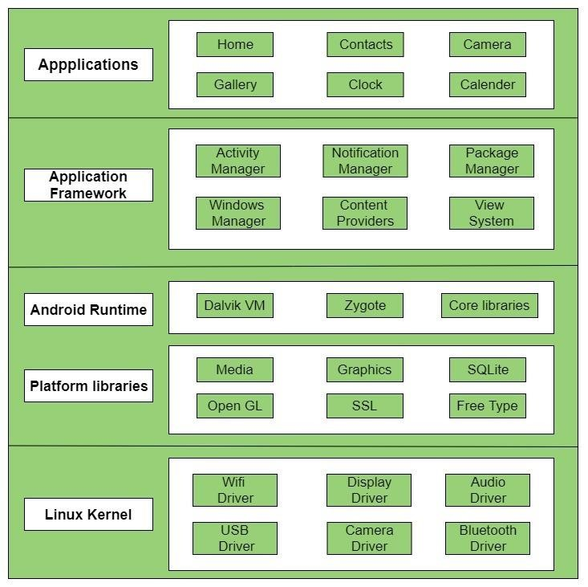

fig 1.5: Android Architecture

## **1.6 ANDROID APPLICATION COMPONENTS**

Application components are the essential building blocks of an Android application. These components are loosely coupled by the application manifest file AndroidManifest.xml that describes each component of the application and how they interact.

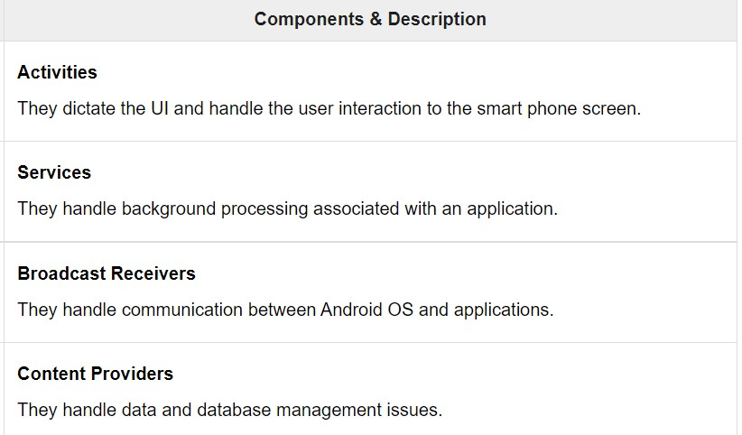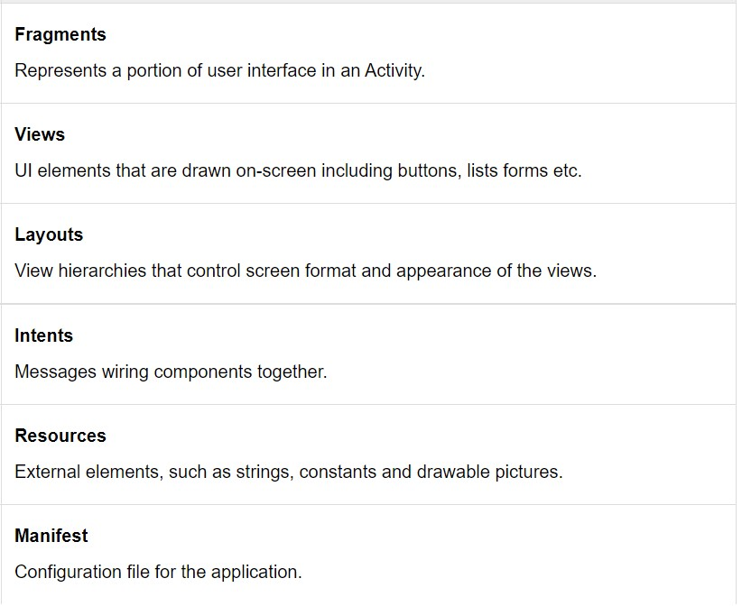

Fig 1.6 Android components

## **1.7 PROBLEM STATEMENT**

Our goal is to develop an innovative fitness app that addresses the challenges and limitations faced by individuals in achieving their fitness goals. The app aims to provide a comprehensive and personalized solution to promote physical activity, improve overall health, and enhance user engagement.

Fitness apps suffer from lack of automation features that allow users to input all required information together much quicker. It's hard to imagine users who would spend time on logging their food every single day for a more extended period. That's why many users abandon these apps after a month or two. Fitness apps are applications designed by companies to keep you fit and healthy. These apps can be downloaded on mobile phones quite easily. The aim of these apps is to make your lifestyle healthier by tracking your food intake, water intake and workout pattern. Some apps even keep a track of your heart rate and blood pressure, which is beneficial for individuals with high blood pressure. Some health and fitness apps even have a health coach, who help their clients to achieve their health goals effectively.

## **1.8 OBJECTIVES**

1. **User Engagement:** The primary objective is to develop a fitness app that captivates users and encourages them to engage actively in their fitness journey. This includes providing an intuitive user interface, personalized content, and interactive features that promote ongoing user interaction and participation.
2. **Accountability and Motivation:** Establish mechanisms within the app to foster accountability and motivation. This includes features such as goal setting, progress tracking, achievement badges, social integration, and challenges. By creating a supportive environment and offering rewards and recognition, the app aims to motivate users to stay committed to their fitness goals.

## **1.9 PROJECT APPLICATION**

1. **Lack of Personalization:** Existing fitness apps often fail to provide personalized workout plans and recommendations tailored to individual needs, goals, and fitness levels. Users may feel overwhelmed or unmotivated due to generic content that does not cater to their specific requirements.
2. **Limited Accountability and Motivation:** Without a supportive environment or accountability mechanisms, individuals often struggle to stay motivated and committed to their fitness goals. The absence of real-time feedback, progress tracking, and social interaction can lead to a lack of consistency and diminished results.
3. **Inefficient Tracking and Measurement:** Many fitness apps rely solely on manual data entry, which can be tedious and time-consuming. Users may find it challenging to accurately track their progress, leading to a lack of insights and an inability to make informed decisions regarding their fitness journey.
4. **Limited Integration and Accessibility:** Users often utilize multiple fitness tools and wearables, resulting in fragmented data and a lack of seamless integration. Additionally, some apps may not be accessible across different devices or platforms, limiting user engagement and convenience.

**CHAPTER-2**

**REQUIREMENT SPECIFICATION**

## **2.1 SOFTWARE REQUIREMENT SPECIFICATION**

* Operating System: 64 Bit Operating System, X64-Based Processor
* Tools: Android Studio, JAVA JDK
* Programming Language: Java

## **2.2 FUNCTIONAL REQUIREMENTS**

The app should be able to count the footsteps. The app can calculate the distance covered by the user. The app should keep an eye on calories burnt. The app should have the option to select muscles to work on and also its exercises. The app should inform with all the procedures/instructions of a particular exercise with a timer.

## **2.3 NON-FUNCTIONAL REQUIREMENTS**

The load time for the user interface screen should take no longer than 5 seconds. Steps should be counted with the least error. Distance and calories burnt should be calculated and displayed alongside. The application should be able to run on any Android device having a minimum Android version 6.0(Marshmallow). The application should be available at all times.

**CHAPTER-3**

# SYSTEM DESIGN

**3.1 EXISTING SYSTEM**

They can be used as a platform to promote healthy behaviour change with personalized workouts, fitness advice and nutrition plans. Fitness apps can work in conjunction with wearable devices to synchronize their health data to third-party devices for easier accessibility.

**3.2 PROPOSED SYSTEM**

**1. Monitor Your Diet Easily:** Weight watchers or people who want to gain weight can mention the type and number of foods consumed at each meal. From this information, health apps calculate the calories, carbohydrates, proteins and fat content of your meal. In this way, you can avoid foods that may not be right for your health. You can track all your food intake easily and maintain a digital food diary at just one click. Studies have found that maintaining a food diary or a food log helps individuals to eat food more consciously.

**2. Monitor Your Progress:** Now you can simply monitor all your workout and health progress at just one click. Fitness apps enable you to fill in all your health details and updates. For example you can record your blood glucose levels and blood pressure levels each time you get them checked. This helps you to track your health details at just one go. You can even compare your current blood parameters with your previous ones, which will give you an idea if your health has improved or not.

**3. Give Free Health and Fitness Tips:** Many health and fitness apps provide health and fitness tips and guidelines, which help individuals in meeting their health goals. You can also get free workout or exercise ideas that help you to plan your workout routine easily.

**4. Track Your Foot Steps:** Pedometer apps are now available on mobile phones, where you can keep a count of steps and track the distance you have walked. Such apps help you meet your step count target by giving you all the information you need. Monitoring your steps can improve your daily step count and work more towards achieving your target.

**5. Provide Personal Health Coaches**: Smartphone technologies have now made life easier. You no longer need to hunt for trainers or health coach or a fitness class. Fitness apps provide excellent facilities to keep you fit and healthy. Some apps have personal health coaches at affordable prices. The coach helps you achieve your fitness goals and educates you about the fitness activities and your diet too. The best part is you don't need to travel for long hours to get this facility. All you need to do is download the app and start a fitness program.

**6. All in One Health Tool:** Fitness apps are like a one-stop station where you can monitor all your lifestyle parameters like step count, diet, water intake, blood parameters and workout routine. You don't need to maintain different diaries or books to keep a record of all these things. Fitness apps help improve your lifestyle habits, as they have a huge positive impact on your health.

**7. Keep You Motivated:** One of the most important benefits of using a fitness app is 'motivation'. Notification and reminders from fitness apps keep reminding you about your health goals, thus keeping you motivated. You may also come across your fitness app various times in a day while using your smartphone. Fitness apps have made our lives easier and enable you to track your activities on a daily basis. Thus, making you stay focused on your activities and overall fitness.

**3.3 ARCHITECTURE**

The proposed architecture depicted below shows the exact flow of control of the android application. Here the database acts as a storing media between the two mobile devices. The database information i.e., to which database the information has to be sent, the URL of the database is coded itself in the application. From the database, the location coordinates are sent continuously to the registered contacts of the user.

**3.4 FLOWCHART**

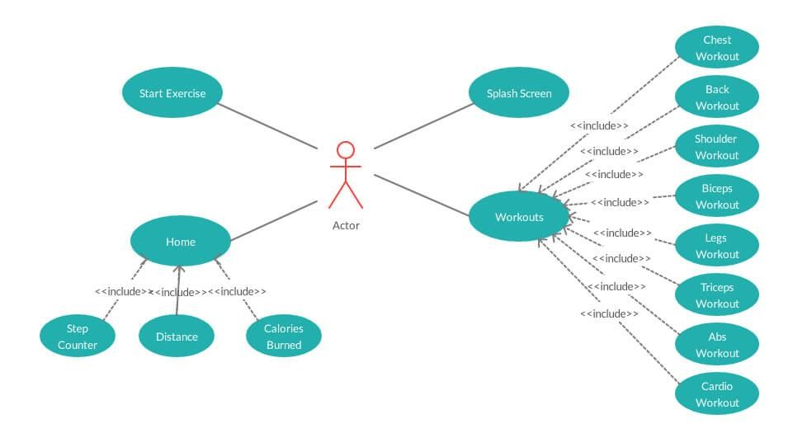

Fig 3.4: Flowchart

**CHAPTER-4**

# 4.1 IMPLEMENTATION

* Fitness apps are all the rage right now. With more and more people paying better attention to their fitness and well-being, fitness apps have become a staple in almost every smartphone. COVID-19 has only accelerated this trend.
* With lesser access to gyms and in-person training, people are relying on virtual classes to stay fit and motivated. Take MyFitnessPal, for example. The product has already generated over $1.4 million in 2020 and is on track to become the top-grossing fitness app of all time. The sole reason to create your workout app should be something else besides the global fitness app [market](https://www.statista.com/statistics/298033/us-health-and-fitness-app-usage-reasons/) reaching $14 billion by 2026.
* Fitness app development benchmarks say your product may enjoy 28% conversion rate, above 50% retention rate, and a 4- or 5-star rating that, if you follow the best practices when you create your own workout app. Third-party libraries with ready-made features. If you are looking for the information to create a personal trainer fitness app that stands out, you’re reading the right guide. [Fitness App Market Wrap-Up.](https://topflightapps.com/ideas/how-to-build-a-fitness-app/#1)
* [Types of Fitness and Workout Apps.](https://topflightapps.com/ideas/how-to-build-a-fitness-app/#2) [Fitness App Features.](https://topflightapps.com/ideas/how-to-build-a-fitness-app/#3) [5 Steps to Create Your Own Fitness Ap](https://topflightapps.com/ideas/how-to-build-a-fitness-app/#4)[p. Research market and choose platform](https://topflightapps.com/ideas/how-to-build-a-fitness-app/#4.1)[. Prototype and user-test.](https://topflightapps.com/ideas/how-to-build-a-fitness-app/#4.2) [Choose the tech stack.](https://topflightapps.com/ideas/how-to-build-a-fitness-app/#4.3) [Build and test, rinse and repeat.](https://topflightapps.com/ideas/how-to-build-a-fitness-app/#4.4) [Release and maintain.](https://topflightapps.com/ideas/how-to-build-a-fitness-app/#4.5) [How Much Does It Cost to Build a Fitness App.](https://topflightapps.com/ideas/how-to-build-a-fitness-app/#5) [Monetization Strategies.](https://topflightapps.com/ideas/how-to-build-a-fitness-app/#6) [Fitness App Development Best Practices.](https://topflightapps.com/ideas/how-to-build-a-fitness-app/#7) [Our Experience in Fitness App Development](https://topflightapps.com/ideas/how-to-build-a-fitness-app/#8) .

# RESULTS

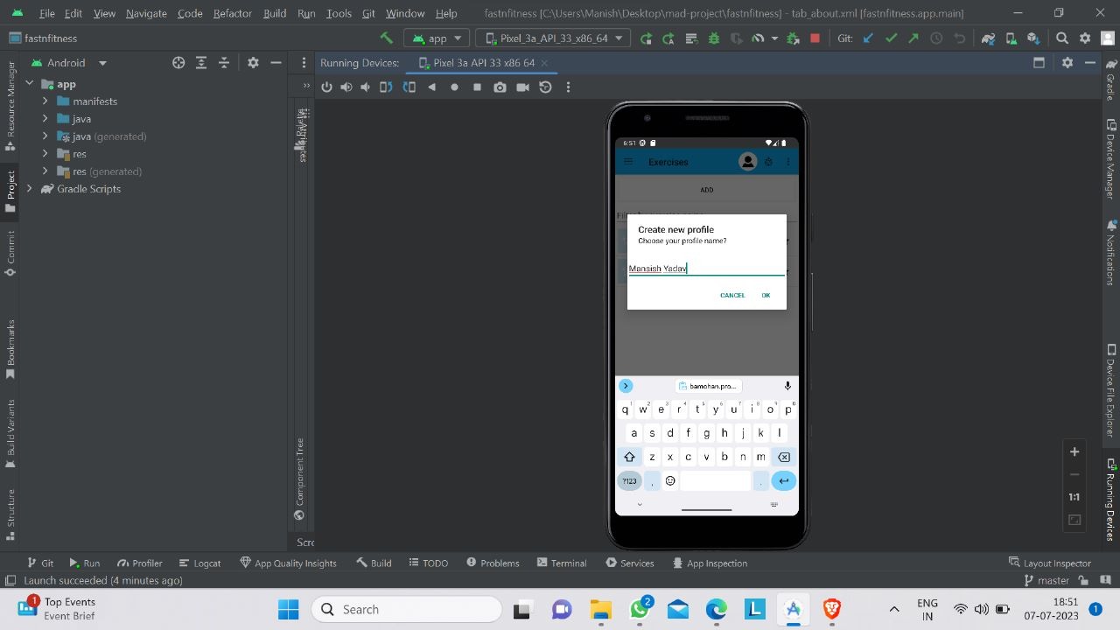

Fig 4.1: Creating a profile

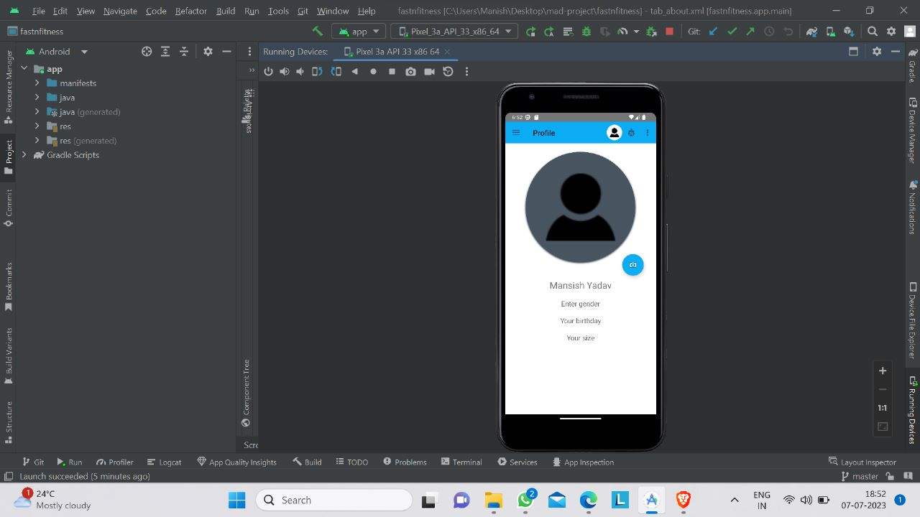

Fig 4.2: Profile

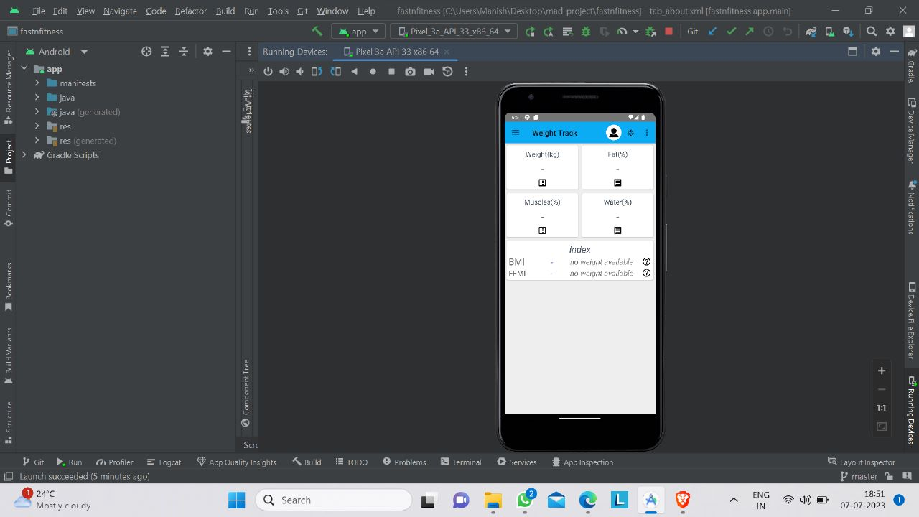

Fig 4.3: Weight Track Page

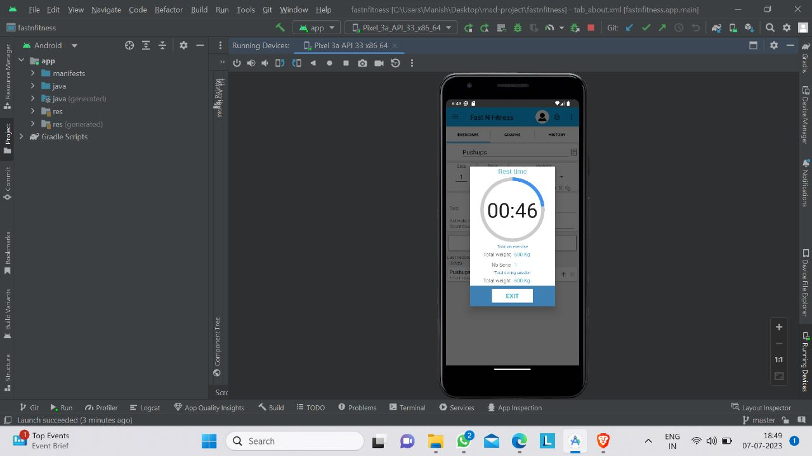

Fig 4.4: Timer

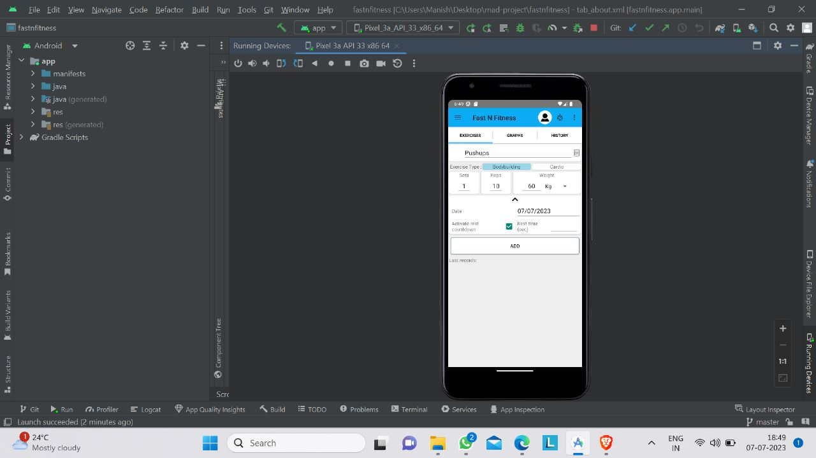

Fig 4.5: Main Page Exercises

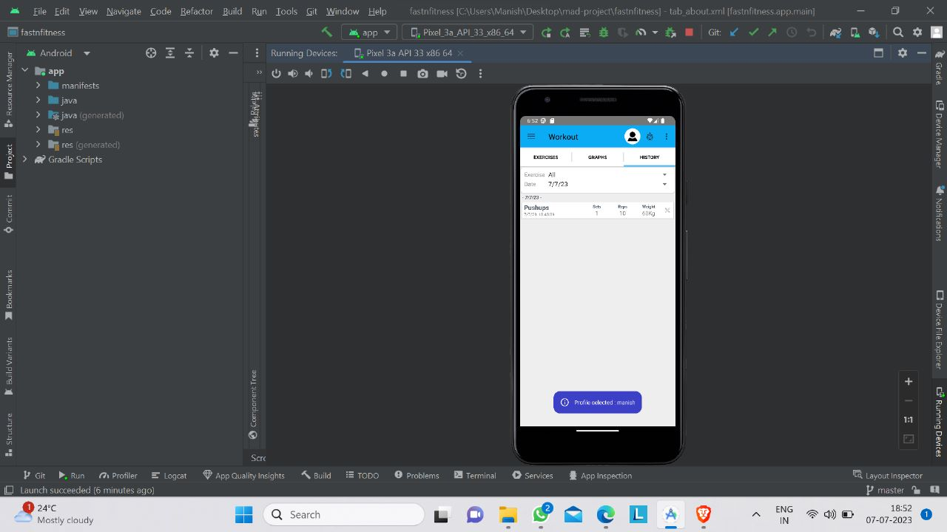

Fig 4.6: Workout History

**CHAPTER-5**

## **5.1 APPLICATION TESTING**

When it comes to testing a fitness app, there are several aspects you should consider to ensure its functionality, usability, and overall user experience. Here are some key areas to focus on during the testing process:

1. Functional Testing: Verify that all the features and functionalities of the fitness app are working as intended. Test various scenarios, such as creating a new user account, logging in/out, tracking workouts, setting goals, and any other core functionality the app offers.

2. Compatibility Testing: Test the app on different devices, operating systems (iOS, Android), and screen resolutions to ensure it works well across various platforms. Pay attention to how the app adapts to different screen sizes and orientations.

3. Performance Testing: Assess the app's performance under different conditions, including normal usage, heavy usage, and low network connectivity. Test the app's responsiveness, loading times, and the impact on device resources (CPU, memory, battery) to ensure it performs optimally.

4. Usability Testing: Evaluate the user interface (UI) and user experience (UX) of the app. Ensure that the app is intuitive, easy to navigate, and visually appealing. Test the app with real users to gather feedback on the app's usability and make improvements accordingly.

5. Security Testing: Verify that the app handles user data securely. Test authentication and authorization mechanisms to prevent unauthorized access. Check for vulnerabilities like data leakage, insecure data storage, and encryption protocols.

6. Compatibility with Fitness Devices: If the app integrates with fitness devices (such as smartwatches, heart rate monitors, or pedometers), test the compatibility and accuracy of data synchronization between the app and the devices.

7. Stress Testing: Simulate heavy user loads to determine how the app performs under high traffic conditions. Test scenarios such as simultaneous logins, concurrent workout tracking, or sharing workout updates on social media.

8. Localization Testing: If the app is intended for a global audience, test its localization and language support. Ensure that translations, date formats, and other local requirements are implemented correctly.

9. Accessibility Testing: Assess the app's accessibility features to ensure it is usable by individuals with disabilities. Test features like text-to-speech, screen reader compatibility, colour contrast, and font size options.

10. Regression Testing: Conduct periodic regression testing to ensure that new feature additions or bug fixes do not introduce new issues or break existing functionality.

Remember to document any issues or bugs you encounter during testing and provide detailed reports to the development team. This will help them address the problems and improve the overall quality of the fitness app.

**CHAPTER-6**

# CONCLUSION

The Fitness apps are applications designed by companies to keep you fit and healthy. These apps can be downloaded on mobile phones quite easily. The aim of these apps is to make your lifestyle healthier by tracking your food intake, water intake and workout pattern.

Some apps even keep a track of your heart rate and blood pressure, which is beneficial for individuals with high blood pressure. Some health and fitness apps even have a health coach, who help their clients to achieve their health goals effectively.

Future enhancements: It has made the world smaller. And, the techies are becoming more and more engrossed with these new advancements in the field of science and technology. And thereby, neglecting their health widely.

This has created a havoc on the health-giving rise to the following disorders. Obesity is certainly one of the worst consequences. Also, abnormalities in blood pressure and level of blood sugar, depression, cardio vascular disorders, anxiety, different types of cancer and many more. The technology hasn’t made our life complicated. Yes, there are some negative impacts on health. But it has provided a lot of alternatives to outnumber the negative ones. Thanks to the technological development that [you can now start exercising](https://www.hereon.biz/under-desk-elliptical/) at your desk right in your workplace.

Several under desk cycles and elliptical bikes have been developed, which no longer create the problem of restricted blood flow and constant inactivity even if you sit for more than 8 hours in your workstation.

**CHAPTER-7**

# REFERENCES

[1]. Android Developers, Location APIs. URL:<http://developer.android.com/google/playservice>s/location.html

[2]. https://nodejs.org/en/docs

[3]. https://devcenter.heroku.com/categories/reference

[4]. https://devcenter.heroku.com/articles/getting-started-with-node